Experiment #2 – Diodes and Applications

# Youssef Samwel

# [yo800238@ucf.edu](mailto:yo800238@ucf.edu)

# EEE3307 Electronics I

Section 0014

# Due Date 10/1/2023

# **Project Description**

# The students were tasked with constructing and analyzing diode-based circuits. The purpose of experiment is to expose the students to application of diodes and types of usage in circuits.

# **2.0 About Laboratory Day**

# The laboratory session took place on the Monday section between 6:00pm and 8:50pm on September 25, 2023. My lab partners were Nicolas and Brandon.

# **3.0 Computer Simulation (SPICE)**

# Pre-Laboratory Simulations

A) For the circuits of Fig. 1 and Fig. 2, choose available values of RL and C so that RLC = 0.2 second approximately. Draw the output waveforms when the input is sinusoidal of frequency 100 Hz and 10 V peak to peak, under the following cases:

1. Capacitor only is removed. Plot the transfer ( versus ) characteristics.
2. Resistor only is removed.
3. Capacitor and resistor are both in place. Calculate the peak-to-peak ripple voltage.

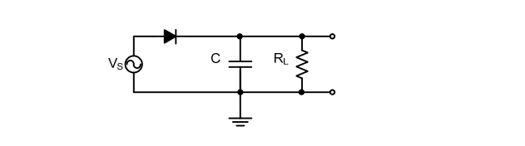

Figure 1

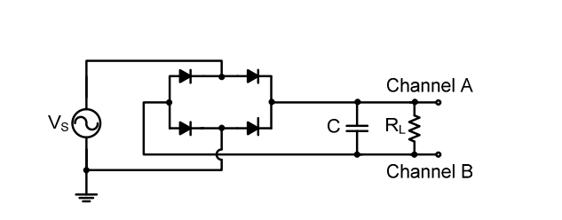

Figure 2

Waveform without Capacitor

Waveform without Resistor

Waveform with both Capacitor and Resistor

To compute the ripple voltage, we use the half-way rectifier equations, as shown below:

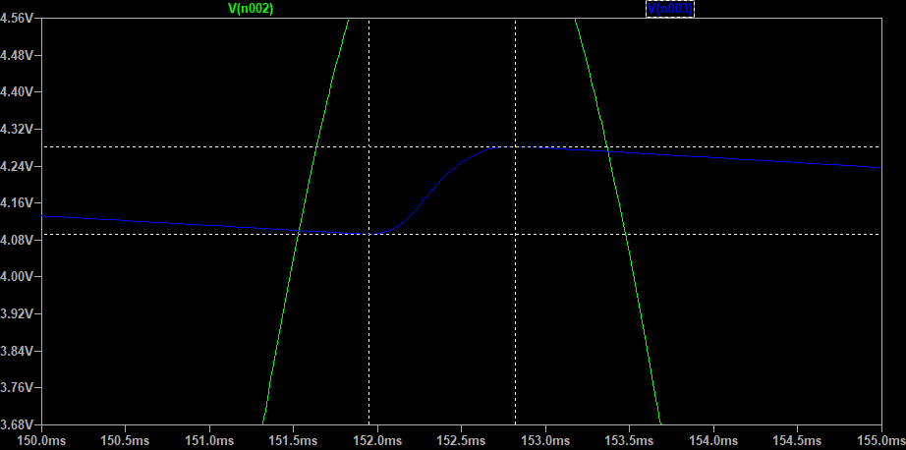The simulated ripple voltage in LT-spice is .

The difference between the simulated value and the computed value is that the equation assumes that the diode has ideal behavior, however, in the simulation, LT-spice accounts for diode non-ideal parameters.

B) Determine the transfer characteristics of the circuits in Fig. 3 and Fig. 4. Draw the output waveforms assuming that the input is a sinusoid with sufficiently larger amplitude (larger than both reference voltages or the Zener voltages) amplitude.

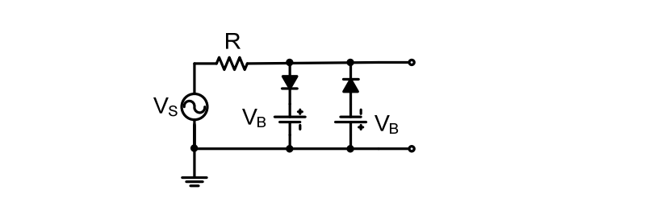

Figure

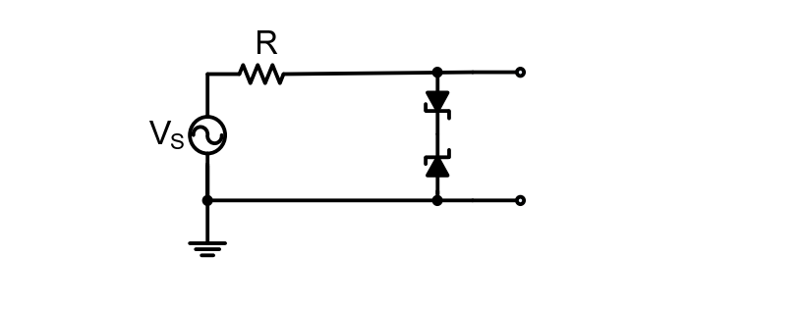

Figure

Input vs Output Voltage for Fig. 3

For we used and the resistance value was .

Input vs Output Voltage for Fig. 4

The breakdown voltage for the Zener diodes in the simulation is which is similar to the diode used in the experiment.

C) For the circuit shown in Fig. 5, draw the output waveform if the input is a sinusoid. Do not neglect the diode turn on voltage (≈ 0.65 V). Select available values of R and C so that RC time constant is equal to 0.2 seconds approximately (e.g., for a capacitor of 10 µF, the resistor value should be 20 kΩ).

Figure 5

Input vs Output Voltage for Fig. 5

# **4.0 Experiment Procedure**

# Clipping Circuits

a) Connect the circuit in Fig. 3. Let the input be a sinusoid of frequency 1 kHz. Display the input and output waveforms on the oscilloscope. Vary the amplitude of the input and observe the result. Display the vs. transfer characteristics of the circuit on the oscilloscope. Change the input waveform to a triangular or square waveform and see what happens.

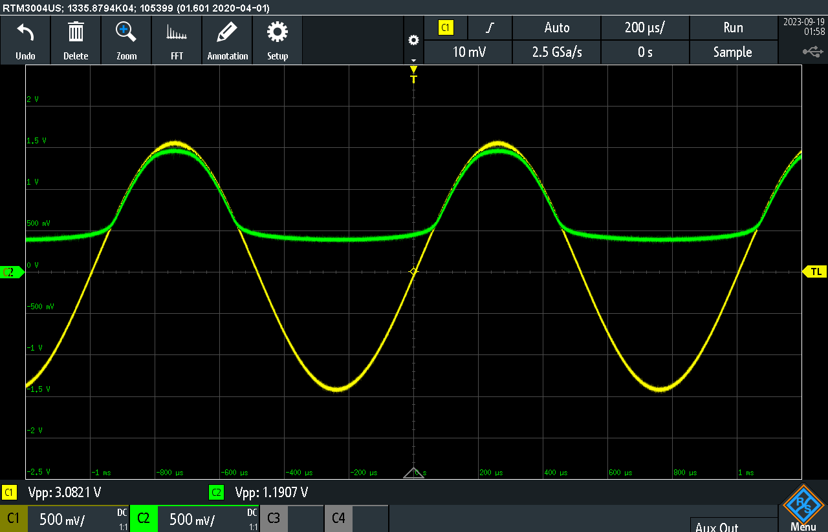

vs. when Vb = 0

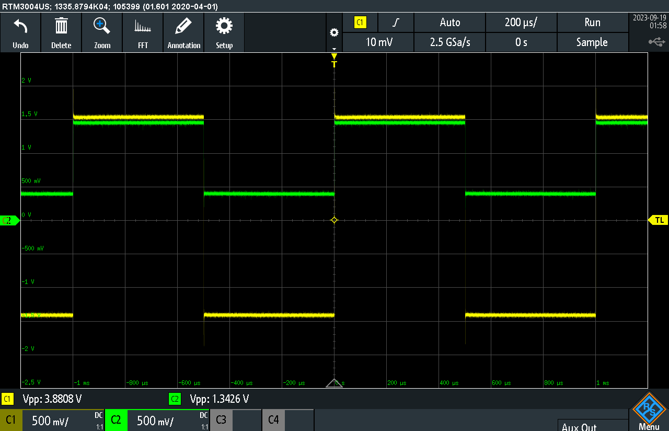

vs. when Vb = 0

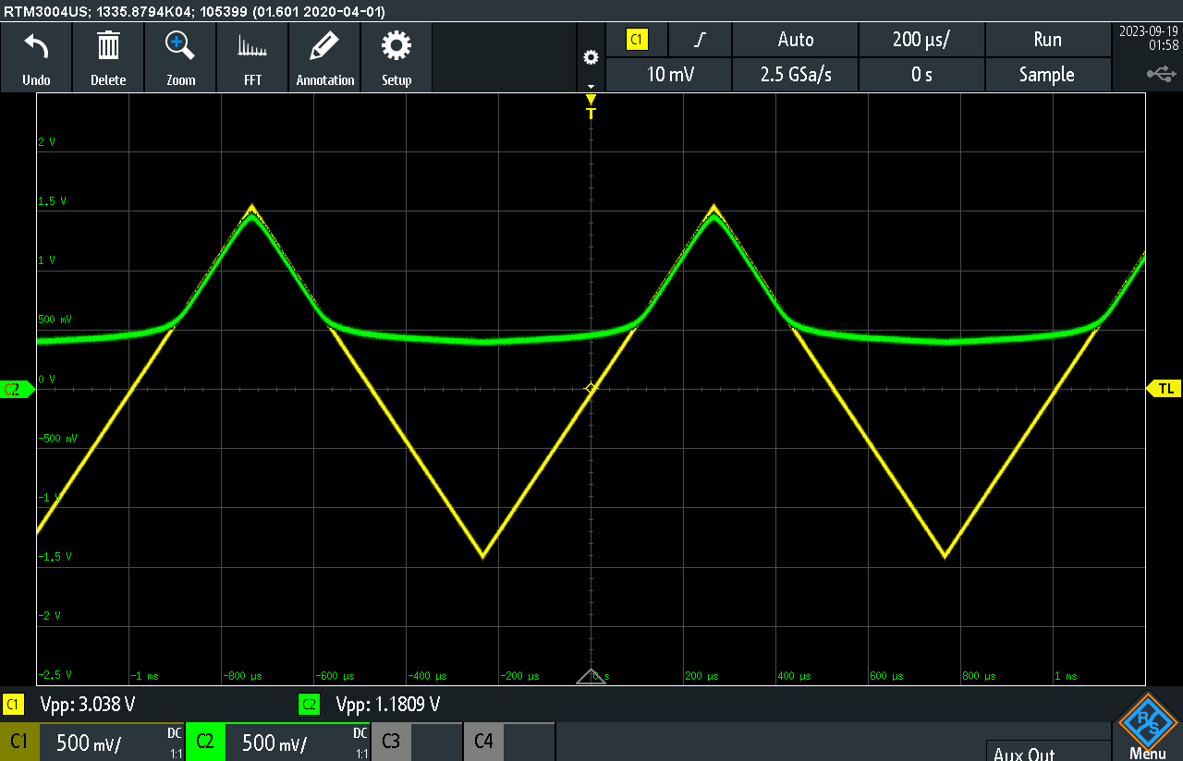

vs. when Vb = 0

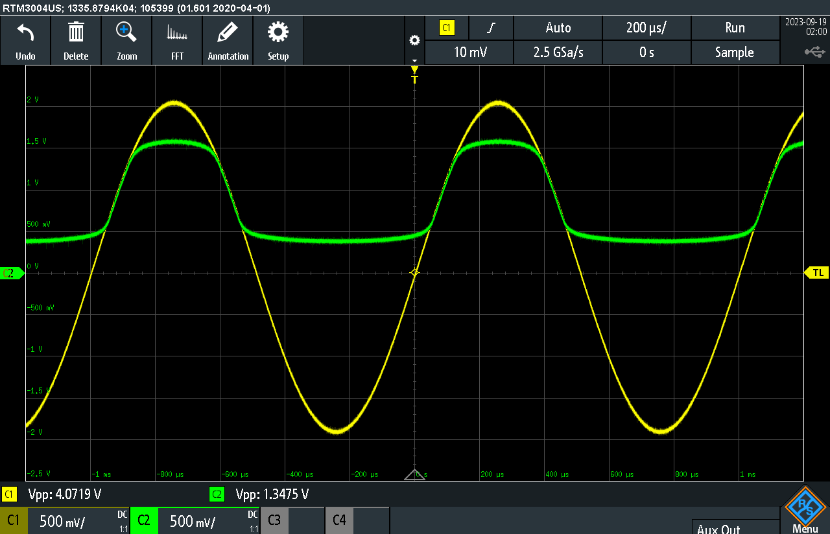

vs. with variable

vs. with variable

vs. with variable

b) Repeat the same steps for the circuit in Fig. 4. Note that the Zener breakdown voltage of 1N5234 is about -6.2 V and Zener diode’s forward turn-on voltage is about 0.65 V. Your input voltage may change to 20 V peak to peak to provide sufficiently larger amplitude.

Sine Wave

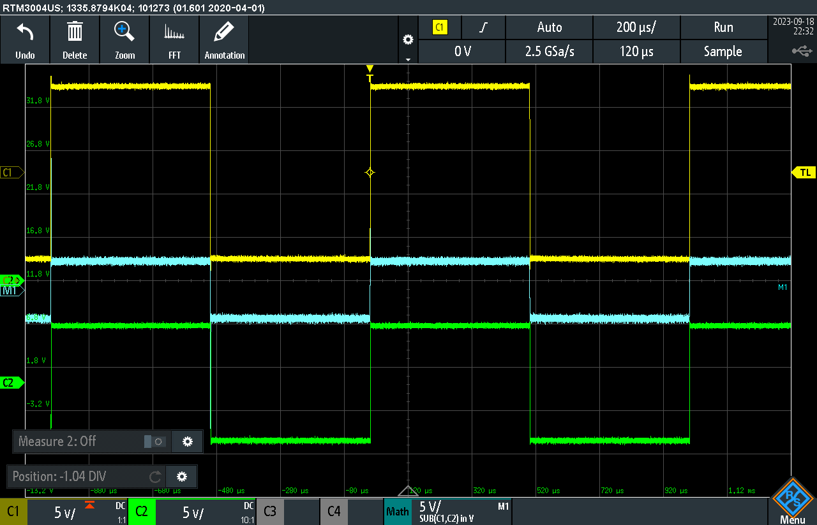

Square Wave

Triangle Wav

# Clamping Circuits

a) Connect the circuit in Fig. 5. Let the input be a sinusoid of any amplitude at 1 kHz. While observing the output waveform (set the oscilloscope scope to be DC coupled), vary the amplitude of the input and observe the result. Next, leave the amplitude the same and add a DC offset in the input (There should be an “offset” control on the generator) and again observe the output. Make comments.

b) Repeat the same steps for a square-wave input.

# **5.0 Observations and Simulation Comparison**

# **6.0 Learned Objectives**

* Use of function generator
* Measurement using oscilloscope and practical probing.
* Simulation via LT-spice
* Diode performances and diode IV curve
* Half-wave rectifier
* DC current measurement

# **7.0 Conclusion**